Lees, omdat jy kan

Picture assisted Dutch reading methodology translated to Afrikaans

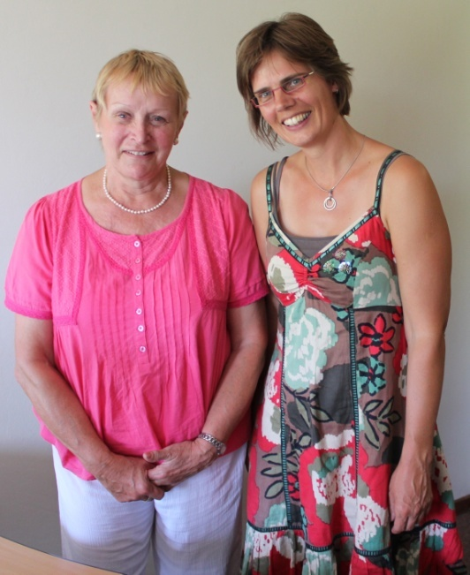
Why would Gerda Bastiaan come to South Africa from the Netherlands to work as a volunteer to help children in Pretoria? She is improving on the translation of the Dutch reading method “Lezen moet je doen” into Afrikaans. This reading method has been developed in the Netherlands by Trijntje de Wit for children with learning difficulties and in Afrikaans it will be called “Lees omdat jy kan”. The initial translation into Afrikaans was done by Rinske Pouwels and Gerda and Prof Anna Hugo at Unisa are working on a second revised edition of this reading method which uses pictures extensively. They are improving on the translation and contextualisation of the text. At the same time they are testing out this reading method in South Africa as a pilot project.
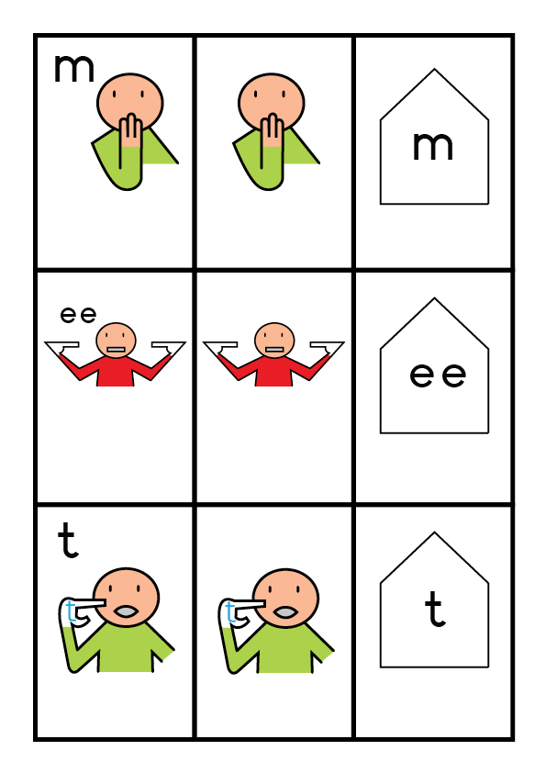
The method is special because:
- It makes use of sounds and physical actions using the entire body. It starts with sounds like aa, oo, m, p, etc. Children with learning difficulties benefit from the support given by accompanying movements which make use of the entire body.
- It uses dual sounds so that i.e. a dyslexic reader learns the support of the sound and is less likely to turn around the letters
- The method builds the skill up slowly and gives success as the children do not need to guess.
- The method slowly replaces the pictures with words and is structured with a great deal of repetition.
Children learn through sounds, actions and pictures or what they see so the reading method links to the development of the learner. The method makes use of the syntax of the sounds which makes up the words; it develops from pictures to sounds, from sounds to words. This is where the methodology differs from other methods that make use of pictures. See examples (left and below) of how these reading materials look.

die
oom sit in die kar
die r r r
die kar ry

die
mamma sit in die bus

die r r r
die bus ry

r r r r r r r r r
picto met 1 letter
. Kyk eers in die algemeen na die bladsy. Wat sien jy alles? Waaroor dink jy gaan die storie?
. Maak die enjin van die kar en die bus baie geraas of is dit sagte enjins? Laat ons hoor: rrr.

LwjkB7.5: +1 Leesteks
In the Netherlands this method is used to teach learners with intellectual disabilities such as autism, and also to those who are deaf. The method also achieves good results with learners who have concentration problems or who have other learning difficulties.
At the start of her career in the Netherlands, Gerda first worked in primary schools. She soon developed a love for the special child, and accepted a position in the special education sector. As an educator she has now been working for years with children with intellectual disabilities and / or autism. Halfway through this time, she opted for a psychiatric nursing degree and now has a Master's degree as a nurse practitioner as well, in order to specialize in students with autism, learning disabilities or psychiatric problems.
When offered an opportunity to come spend a year working with the children and mothers in Genadeplaas, she was very keen. Driven by the desire to help children in a different context in a country struggling with severe educational challenges, she accepted the opportunity to work with this vulnerable group of children. She started using this reading method to get the children back into reading as they struggled with a lack of concentration, had emotional / psychological problems and sometimes battled due to an intellectual disability.
Gerda is convinced that it is important, when living in a vicious circle of poverty and emotional problems that children are offered peace and security. They can then work on their self-esteem and schooling, which in turn allows them to become emotionally calmer and open to their own development.
From October 2012 she once again visited South Africa for three months to do more volunteer work for Genadeplaas. In this time she made arrangements for the training of teachers / daycare persons in Reagile Township and at a Christian College in Kwamshlanga. She is also very excited about working on the fine tuning of the “Lees omdat jy kan” reading method together with Prof. Anna Hugo. As a pilot, Gerda started teaching this method to learners at Genadeplaas, at Unica School and with a child who has Down Syndrome. Three Unisa students who are also teachers have volunteered to also contribute to the pilot study under Anna’s supervision.

